1. Project Title and Description
Title: SSL Architecture and Interior Design
Overview:
SSL Architecture and Interior Design is a full-stack web application that acts as a professional portfolio and client interface for an architectural design firm. This project includes services overview, a team section, a slider-based gallery, and an order management system powered by Django on the backend.
Why I Made This:
To gain experience building a realistic, functional web application that combines design aesthetics with backend functionality. I aimed to simulate how real companies engage users through structured interfaces and dynamic operations.
2. Real-Life Usefulness
- For Clients: Allows users to explore services by budget, view past projects, and submit orders or inquiries.
- For Businesses: Provides architecture firms with a structured online portfolio and a client management tool.
- Scalability: Can be extended to support user authentication, online payments, and more.
3. Technologies Used and Purpose
Technology | Purpose
Django | Backend framework for routing, database, and API endpoints
HTML/CSS | Structure and style the frontend layout
JavaScript | Animation, DOM manipulation, dynamic content
Bootstrap | Used for responsive layouts in order.html
Font Awesome | Iconography
SQLite (via Django) | Data persistence for order records
Why Django:
- Easy to set up and scale
- Built-in admin interface
- Template engine simplifies dynamic page rendering
- Powerful ORM for database interaction
4. Design and Development Process
Backend (Django):
- Defined models for storing order data (name, address, phone, package)
- Created API views for CRUD operations
- Integrated pagination logic
- Used Django’s development server for local testing
Frontend:
- HTML templates styled using CSS and enhanced with JS
- Services section dynamically filters by budget
- Slider component highlights features
- Order page fetches real data via API
AJAX Interaction:
- Orders are retrieved, edited, and deleted asynchronously using JavaScript fetch() API
5. Flowchart of Application
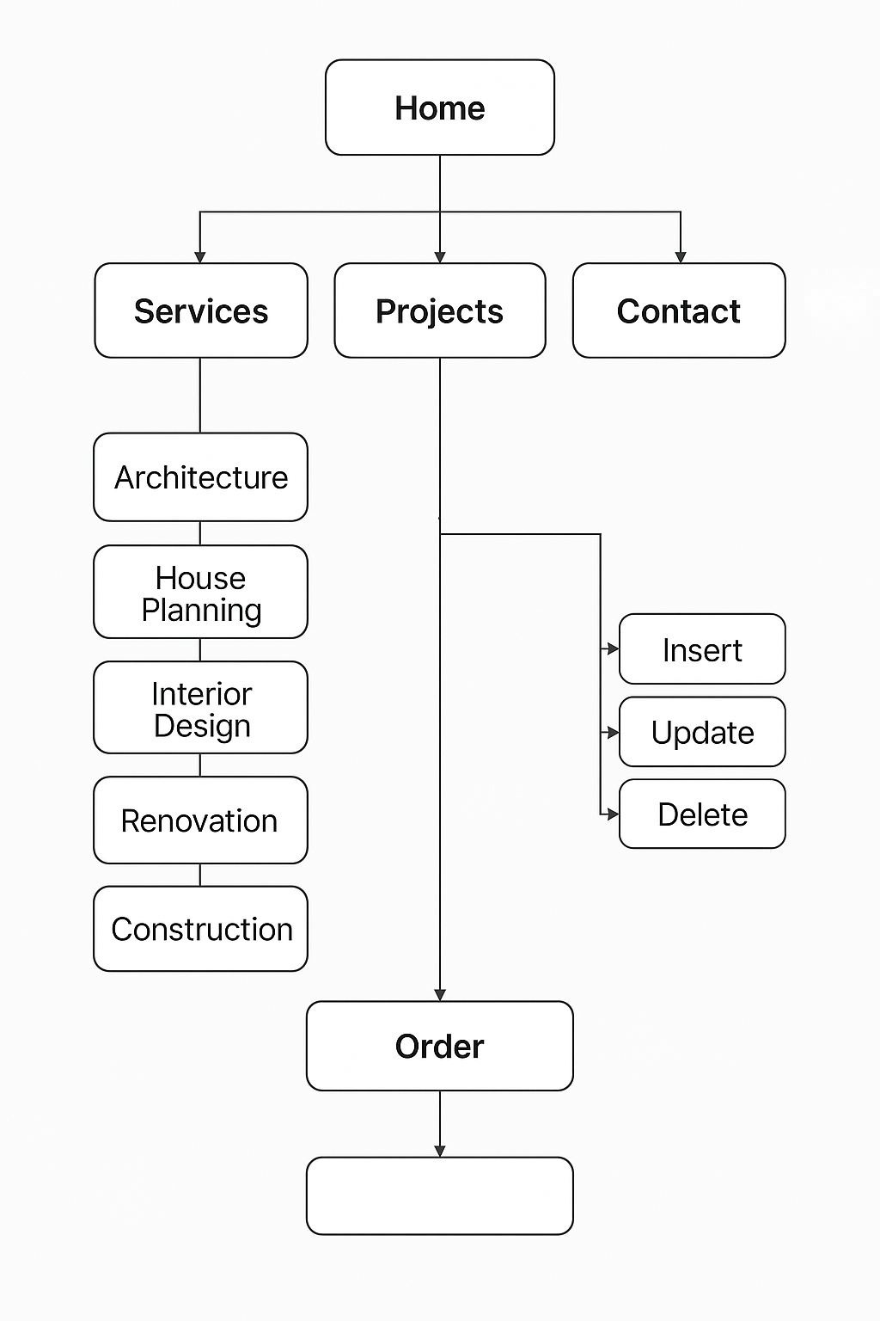
6. Screenshots
- Homepage
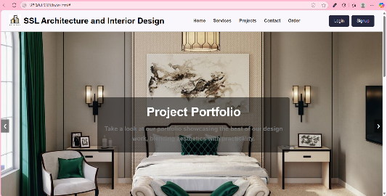
- Services
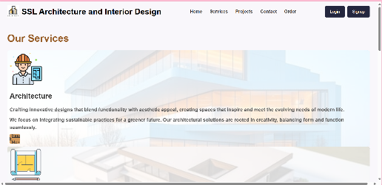

- Project
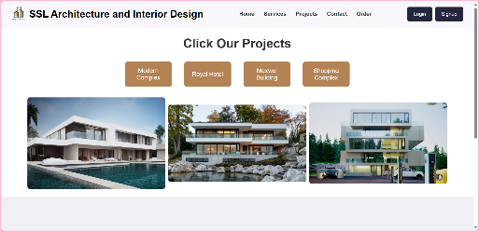
- Contact
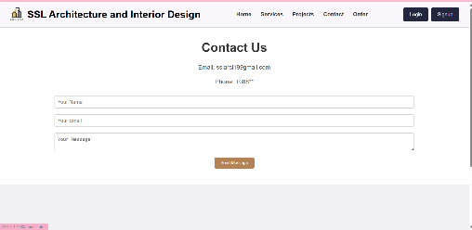
- Order
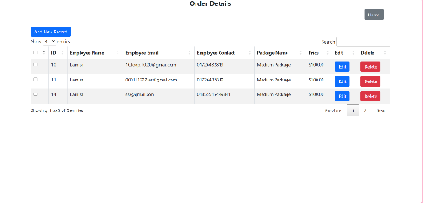
7. Conclusion
This project showcases a professional web presence for architecture firms, combining user-centric frontend design with powerful backend data handling. Django's integration provided robust tools for rapid development and scalable features like API support and model-based forms.
Through this, I learned how to:
- Combine frontend and backend efficiently
- Handle real-time user interaction
- Use Django's REST-style API endpoints
- Structure a modular and clean project
This is not only a valuable portfolio project but also a practical foundation for real-world freelancing or business needs.

